**SYEDA FATIMA SHAH**

**22nd March 2023**

***Task # 5:***

**Write a few lines about Data Types In SQL with examples:**

MySQL Data Types

A list of data types used in MySQL database. This is based on MySQL 8.0.

**MySQL String Data Types**10s

|  |  |
| --- | --- |
| **CHAR(Size)** | It is used to specify a fixed length string that can contain numbers, letters, and special characters. Its size can be 0 to 255 characters. Default is 1. |
| **VARCHAR(Size)** | It is used to specify a variable length string that can contain numbers, letters, and special characters. Its size can be from 0 to 65535 characters. |
| **BINARY(Size)** | It is equal to CHAR() but stores binary byte strings. Its size parameter specifies the column length in the bytes. Default is 1. |
| **VARBINARY(Size)** | It is equal to VARCHAR() but stores binary byte strings. Its size parameter specifies the maximum column length in bytes. |
| **TEXT(Size)** | It holds a string that can contain a maximum length of 255 characters. |
| **TINYTEXT** | It holds a string with a maximum length of 255 characters. |
| **MEDIUMTEXT** | It holds a string with a maximum length of 16,777,215. |
| **LONGTEXT** | It holds a string with a maximum length of 4,294,967,295 characters. |
| **ENUM(val1, val2, val3,...)** | It is used when a string object having only one value, chosen from a list of possible values. It contains 65535 values in an ENUM list. If you insert a value that is not in the list, a blank value will be inserted. |
| **SET( val1,val2,val3,....)** | It is used to specify a string that can have 0 or more values, chosen from a list of possible values. You can list up to 64 values at one time in a SET list. |
| **BLOB(size)** | It is used for BLOBs (Binary Large Objects). It can hold up to 65,535 bytes. |

**MySQL Numeric Data Types**

|  |  |
| --- | --- |
| **BIT(Size)** | It is used for a bit-value type. The number of bits per value is specified in size. Its size can be 1 to 64. The default value is 1. |
| **INT(size)** | It is used for the integer value. Its signed range varies from -2147483648 to 2147483647 and unsigned range varies from 0 to 4294967295. The size parameter specifies the max display width that is 255. |
| **INTEGER(size)** | It is equal to INT(size). |
| **FLOAT(size, d)** | It is used to specify a floating point number. Its size parameter specifies the total number of digits. The number of digits after the decimal point is specified by **d** parameter. |
| **FLOAT(p)** | It is used to specify a floating point number. MySQL used p parameter to determine whether to use FLOAT or DOUBLE. If p is between 0 to24, the data type becomes FLOAT (). If p is from 25 to 53, the data type becomes DOUBLE(). |
| **DOUBLE(size, d)** | It is a normal size floating point number. Its size parameter specifies the total number of digits. The number of digits after the decimal is specified by d parameter. |
| **DECIMAL(size, d)** | It is used to specify a fixed point number. Its size parameter specifies the total number of digits. The number of digits after the decimal parameter is specified by **d** parameter. The maximum value for the size is 65, and the default value is 10. The maximum value for **d** is 30, and the default value is 0. |
| **DEC(size, d)** | It is equal to DECIMAL(size, d). |
| **BOOL** | It is used to specify Boolean values true and false. Zero is considered as false, and nonzero values are considered as true. |

**MySQL Date and Time Data Types**

|  |  |
| --- | --- |
| **DATE** | It is used to specify date format YYYY-MM-DD. Its supported range is from '1000-01-01' to '9999-12-31'. |
| **DATETIME(fsp)** | It is used to specify date and time combination. Its format is YYYY-MM-DD hh:mm:ss. Its supported range is from '1000-01-01 00:00:00' to 9999-12-31 23:59:59'. |
| **TIMESTAMP(fsp)** | It is used to specify the timestamp. Its value is stored as the number of seconds since the Unix epoch('1970-01-01 00:00:00' UTC). Its format is YYYY-MM-DD hh:mm:ss. Its supported range is from '1970-01-01 00:00:01' UTC to '2038-01-09 03:14:07' UTC. |
| **TIME(fsp)** | It is used to specify the time format. Its format is hh:mm:ss. Its supported range is from '-838:59:59' to '838:59:59' |
| **YEAR** | It is used to specify a year in four-digit format. Values allowed in four digit format from 1901 to 2155, and 0000. |

SQL Server Data Types

**SQL Server String Data Type**

|  |  |
| --- | --- |
| **char(n)** | It is a fixed width character string data type. Its size can be up to 8000 characters. |
| **varchar(n)** | It is a variable width character string data type. Its size can be up to 8000 characters. |
| **varchar(max)** | It is a variable width character string data types. Its size can be up to 1,073,741,824 characters. |
| **text** | It is a variable width character string data type. Its size can be up to 2GB of text data. |
| **nchar** | It is a fixed width Unicode string data type. Its size can be up to 4000 characters. |
| **nvarchar** | It is a variable width Unicode string data type. Its size can be up to 4000 characters. |
| **ntext** | It is a variable width Unicode string data type. Its size can be up to 2GB of text data. |
| **binary(n)** | It is a fixed width Binary string data type. Its size can be up to 8000 bytes. |
| **varbinary** | It is a variable width Binary string data type. Its size can be up to 8000 bytes. |
| **image** | It is also a variable width Binary string data type. Its size can be up to 2GB. |

**SQL Server Numeric Data Types**

|  |  |
| --- | --- |
| **bit** | It is an integer that can be 0, 1 or null. |
| **tinyint** | It allows whole numbers from 0 to 255. |
| **Smallint** | It allows whole numbers between -32,768 and 32,767. |
| **Int** | It allows whole numbers between -2,147,483,648 and 2,147,483,647. |
| **bigint** | It allows whole numbers between -9,223,372,036,854,775,808 and 9,223,372,036,854,775,807. |
| **float(n)** | It is used to specify floating precision number data from -1.79E+308 to 1.79E+308. The n parameter indicates whether the field should hold the 4 or 8 bytes. Default value of n is 53. |
| **real** | It is a floating precision number data from -3.40E+38 to 3.40E+38. |
| **money** | It is used to specify monetary data from -922,337,233,685,477.5808 to 922,337,203,685,477.5807. |

**SQL Server Date and Time Data Type**

|  |  |
| --- | --- |
| **datetime** | It is used to specify date and time combination. It supports range from January 1, 1753, to December 31, 9999 with an accuracy of 3.33 milliseconds. |
| **datetime2** | It is used to specify date and time combination. It supports range from January 1, 0001 to December 31, 9999 with an accuracy of 100 nanoseconds |
| **date** | It is used to store date only. It supports range from January 1, 0001 to December 31, 9999 |
| **time** | It stores time only to an accuracy of 100 nanoseconds |
| **timestamp** | It stores a unique number when a new row gets created or modified. The time stamp value is based upon an internal clock and does not correspond to real time. Each table may contain only one-time stamp variable. |

**SQL Server Other Data Types**

|  |  |
| --- | --- |
| **Sql_variant** | It is used for various data types except for text, timestamp, and ntext. It stores up to 8000 bytes of data. |
| **XML** | It stores XML formatted data. Maximum 2GB. |
| **cursor** | It stores a reference to a cursor used for database operations. |
| **table** | It stores result set for later processing. |
| **uniqueidentifier** | It stores GUID (Globally unique identifier). |

Oracle Data Types

**Oracle String data types**

|  |  |
| --- | --- |
| **CHAR(size)** | It is used to store character data within the predefined length. It can be stored up to 2000 bytes. |
| **NCHAR(size)** | It is used to store national character data within the predefined length. It can be stored up to 2000 bytes. |
| **VARCHAR2(size)** | It is used to store variable string data within the predefined length. It can be stored up to 4000 byte. |
| **VARCHAR(SIZE)** | It is the same as VARCHAR2(size). You can also use VARCHAR(size), but it is suggested to use VARCHAR2(size) |
| **NVARCHAR2(size)** | It is used to store Unicode string data within the predefined length. We have to must specify the size of NVARCHAR2 data type. It can be stored up to 4000 bytes. |

**Oracle Numeric Data Types**

|  |  |
| --- | --- |
| **NUMBER(p, s)** | It contains precision p and scale s. The precision p can range from 1 to 38, and the scale s can range from -84 to 127. |
| **FLOAT(p)** | It is a subtype of the NUMBER data type. The precision p can range from 1 to 126. |
| **BINARY_FLOAT** | It is used for binary precision( 32-bit). It requires 5 bytes, including length byte. |
| **BINARY_DOUBLE** | It is used for double binary precision (64-bit). It requires 9 bytes, including length byte. |

**Oracle Date and Time Data Types**

|  |  |
| --- | --- |
| **DATE** | It is used to store a valid date-time format with a fixed length. Its range varies from January 1, 4712 BC to December 31, 9999 AD. |
| **TIMESTAMP** | It is used to store the valid date in YYYY-MM-DD with time hh:mm:ss format. |

**Oracle Large Object Data Types (LOB Types)**

|  |  |
| --- | --- |
| **BLOB** | It is used to specify unstructured binary data. Its range goes up to 232-1 bytes or 4 GB. |
| **BFILE** | It is used to store binary data in an external file. Its range goes up to 232-1 bytes or 4 GB. |
| **CLOB** | It is used for single-byte character data. Its range goes up to 232-1 bytes or 4 GB. |
| **NCLOB** | It is used to specify single byte or fixed length multibyte national character set (NCHAR) data. Its range is up to 232-1 bytes or 4 GB. |
| **RAW(size)** | It is used to specify variable length raw binary data. Its range is up to 2000 bytes per row. Its maximum size must be specified. |
| **LONG RAW** | It is used to specify variable length raw binary data. Its range up to 231-1 bytes or 2 GB, per row. |

**In short the main datatypes are:**

***Task # 6:***

**Practice about following in SSMS:**

**1 - SQL Constrains:**

**• Not Null, Unique, Default and Check constraints**

**• Primary Key and Referential Integrity or foreign key constraints**

**2 - Tables**

**• Creating Table**

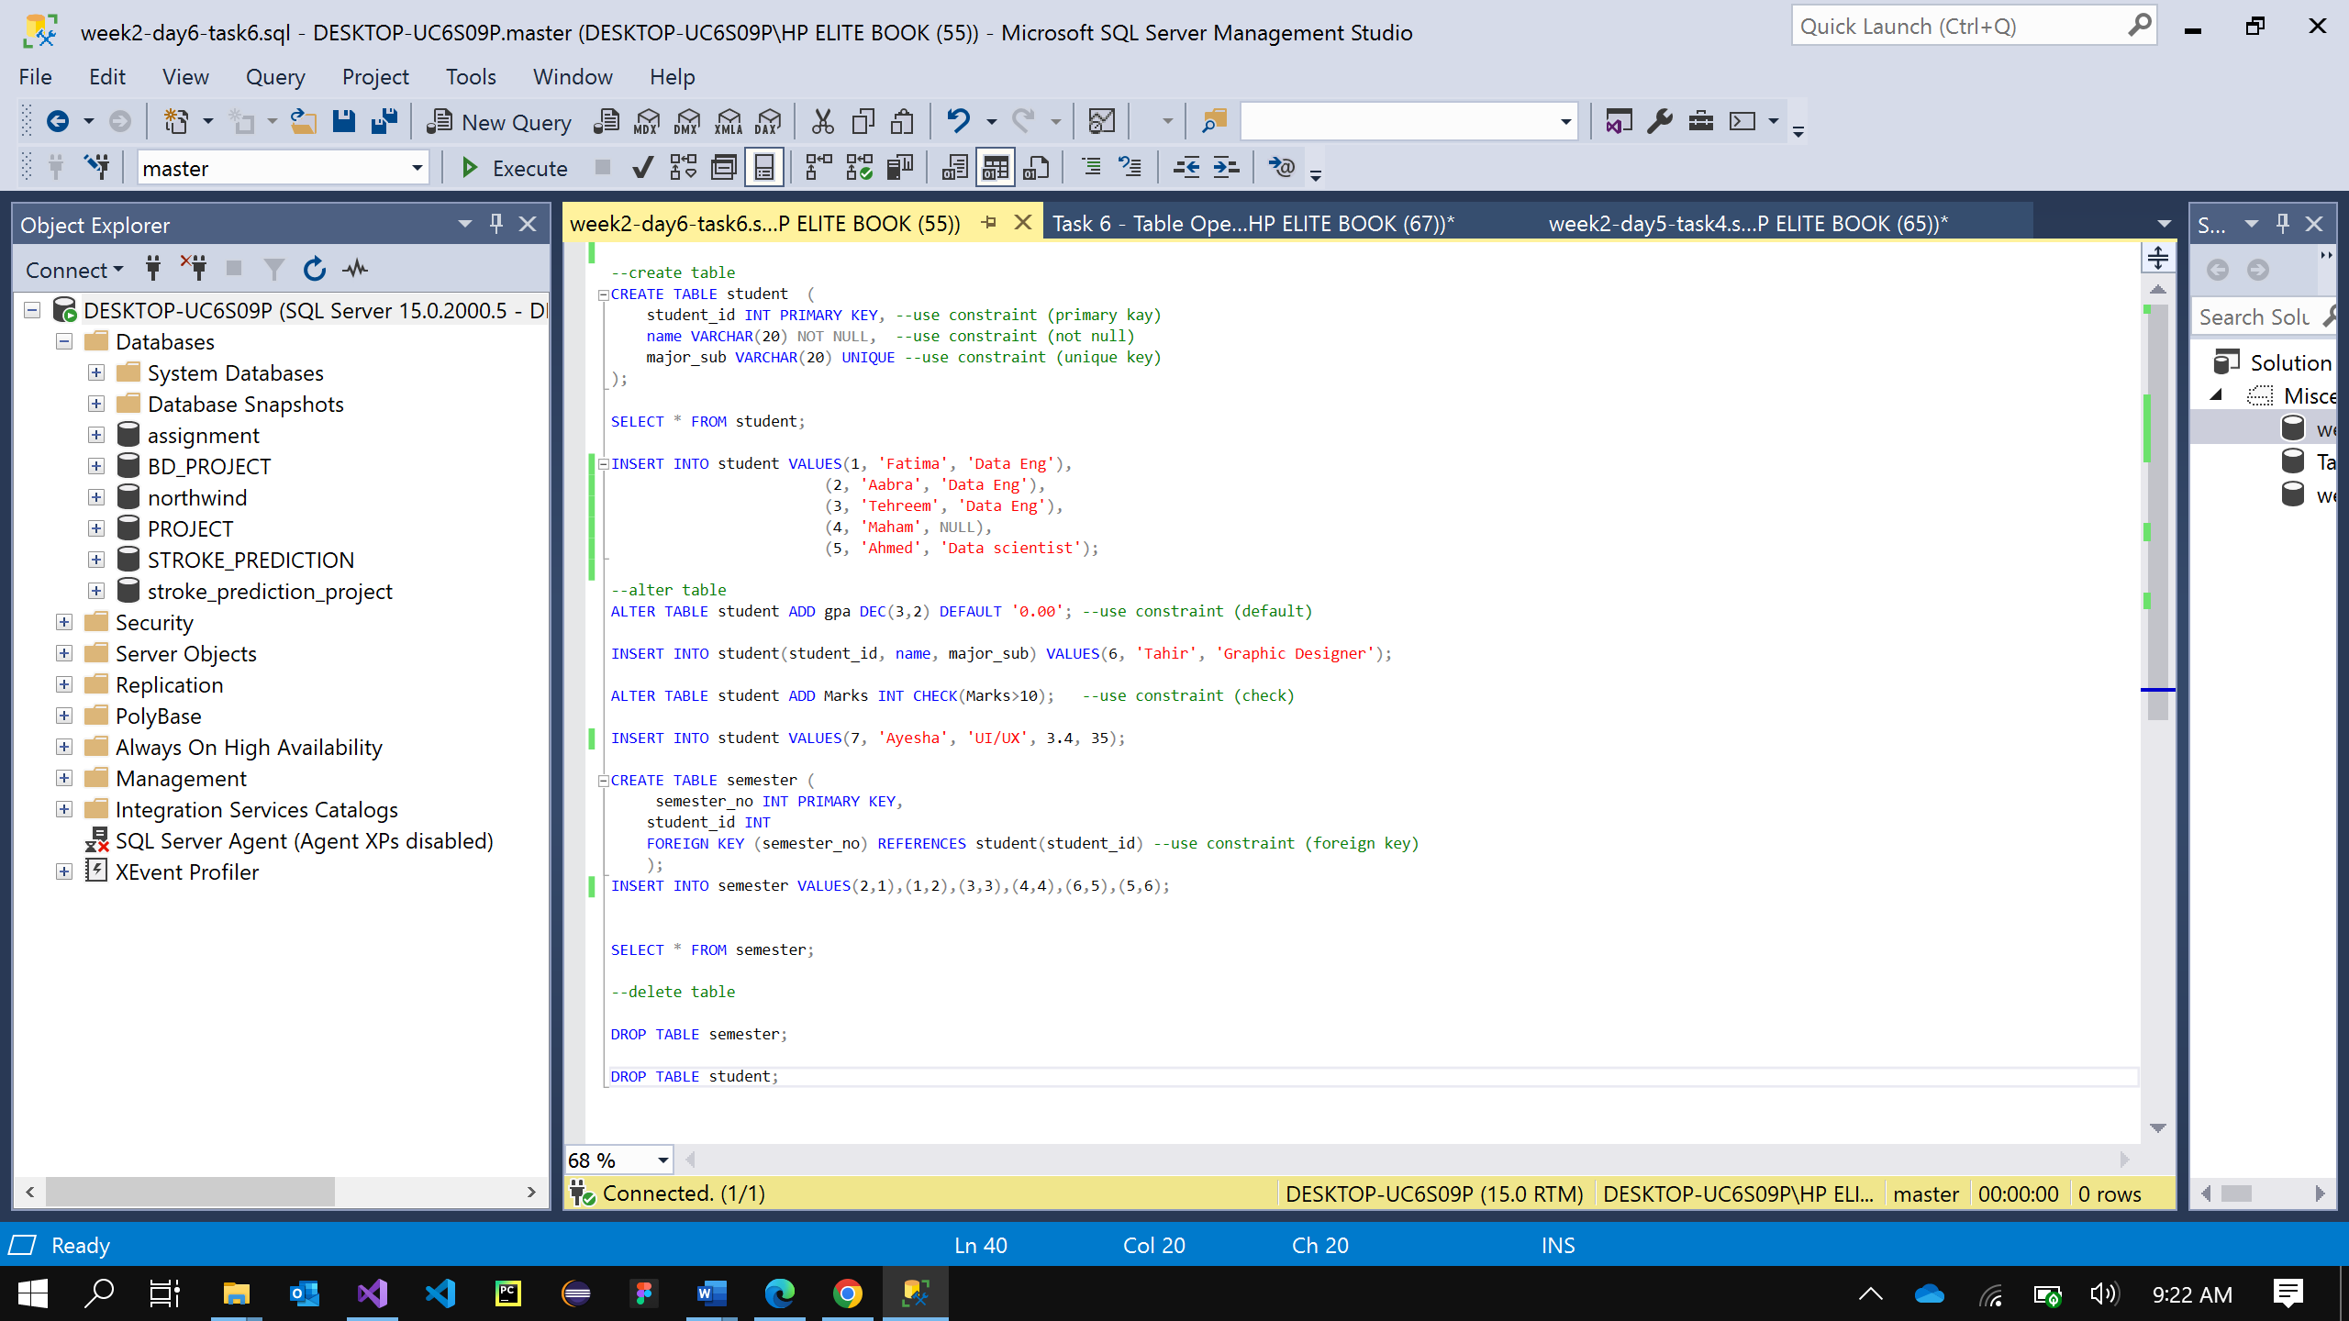

**• Altering Table**

**• Deleting Table**

